Findings for making a capacitor charging circuit

1. OrCAD is causing some issues with initial conditions on the capacitor, yet to be resolved. Circuit under consideration (originally designed by Anshu; slight modifications made while implementing):

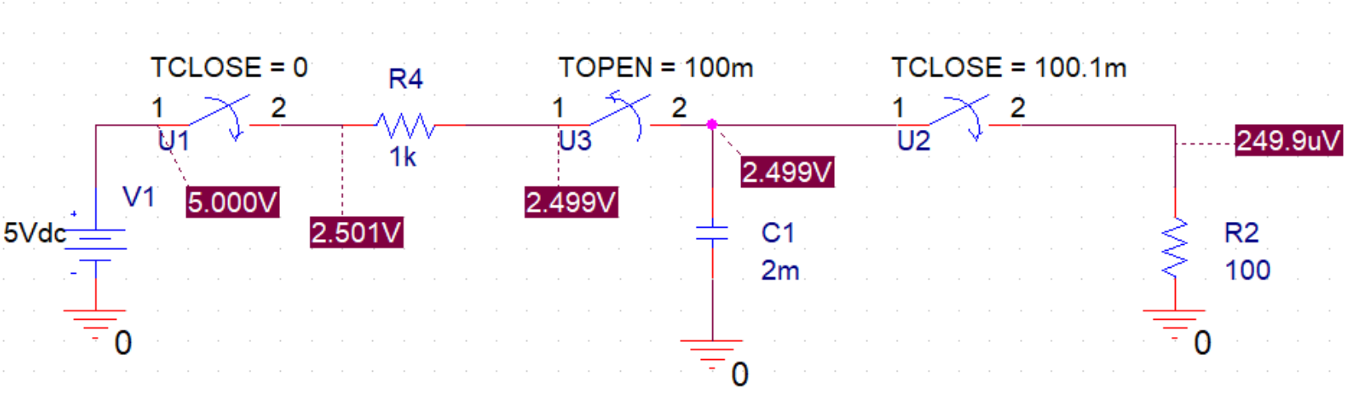

1. The presence of $R_{4}$ between the two switches is very important. Without that, whatever initial voltage the capacitor has, we would get a very large current and would be sufficient to cause significant damage to the circuit. With a $1KΩ$ resistor and $2mF$ capacitor, the initial current through the resistor would be $5mA$; to get a perspective, replace that with $1Ω$ and the current reaches $5mA$. Making a short circuit between the switches will cause the current to shoot up indefinitely. In general, the equation for current through the $RC$ charging circuit is, assuming $R_{4}=1KΩ$ is

$$i_{charging}\left(t\right)=\left(5mA\right)e^{-\frac{1}{RC}t}$$

Based on this, at time $t=0$, $i_{charging}\left(t\right)=5mA$ as mentioned before. However, this again indicates that the initial condition should be $0V$ on the capacitor.

1. BJT is a feasible option to use as a switch in this case. To do so, we use the collector and the emitter as two ends of the switch, while the base is used for biasing. When $V_{BE}<V_{BE,on}$, the switch is deactivated and no current can flow through the BJT, essentially making it an open circuit. Meanwhile, to make a closed switch, we can operate the BJT in saturation. An ideal BJT has $V_{CE,sat}=0V$ but a real BJT would have $V_{CE,sat}∈\left(100,200mV\right)$, so we would have to account for some voltage across the switch (it will never be as high as $2.5V$ as OrCAD is showing though).
2. We determined we need $3.7V$ across the motor (the load in this case). My question for Nick is, if the voltage goes over the limit, would the motor sustain some damage? Because if we go anywhere under that voltage, the motor will turn off. (One solution I am considering is that we use a big capacitor. What this does is that since $q=CV$, $Δq=CΔV$, that is, discharging will change the voltage and not the capacitance. If the capacitance is big, the voltage across the capacitor will change slowly. However, a large capacitor will also mean that it takes longer to charge the capacitor.)
3. A proposed circuit:

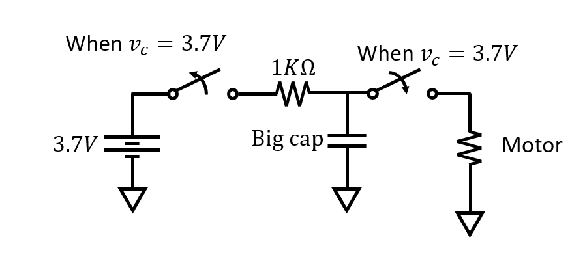

I will try an implementation of this with BJT switches if that seems like a feasible thing to do at office hours. As a reference for BJT switches, here is a link: <https://www.allaboutcircuits.com/textbook/semiconductors/chpt-4/transistor-switch-bjt/>